**My Bro Can Make a Homepage**

**STEP 1:**

**NOTE: In order to complete the homepage as fast as possible my bro should work smartly. Copy codes from google and websites wherever u can and modify them don’t start from scratch.** 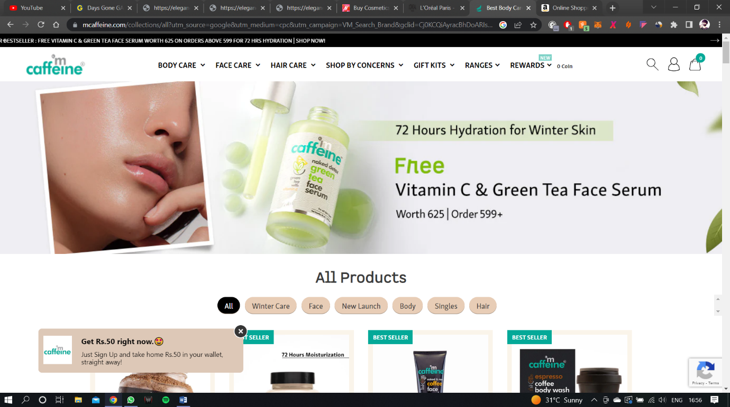

**My bro needs to make a navigation bar but smartly**<https://codemyui.com/material-design-drop-down-navigation-menu/>

Copy the code from above link I like that navigation menu its simple. Don’t go on making the navigation menu from scratch my bro it may take days.

<https://codemyui.com/tag/navigation-menu/>

there are 90 cool navigation bar menus with code on the above site but most of them are full page or to flashy so I choose a simple among them. U can see for urself my bro.

**STEP 2:** 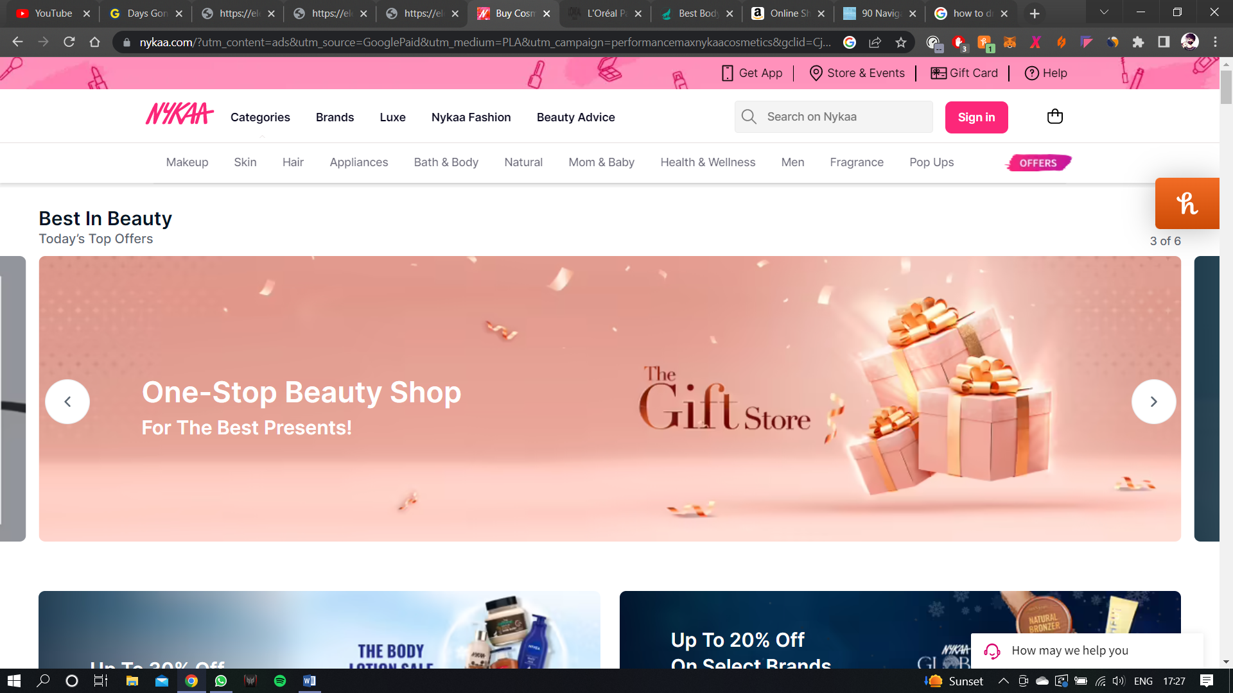

My bro make a big banner scrollable strip like this in nykaa. Add 4-5 dummy banner cards with Dummy heading text on above.

<https://stackoverflow.com/questions/55874049/how-to-make-a-horizontal-scrolling-strip-with-divs-partly-out-of-viewport>

copy code from above save time.  
<https://owlcarousel2.github.io/OwlCarousel2/>

also u can use this idk what is this u check it out

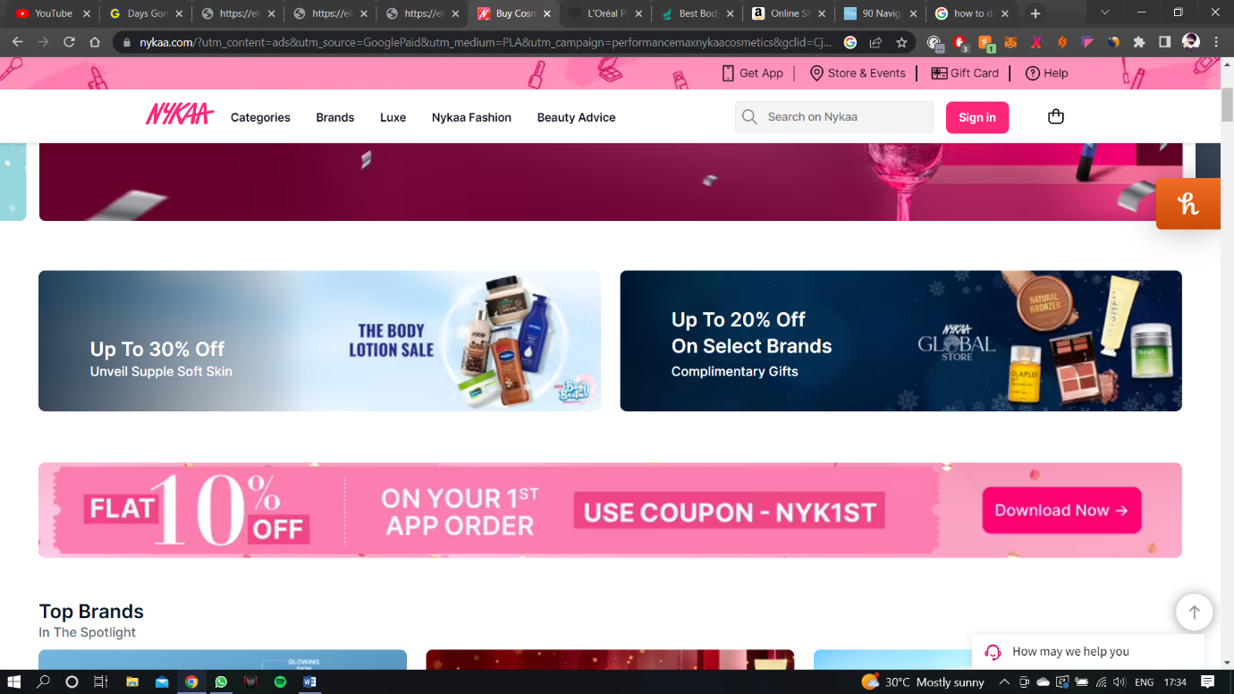

Now my bro should some 4-5 random containers like above so we can brag about our website on it.  
**STEP 3:** 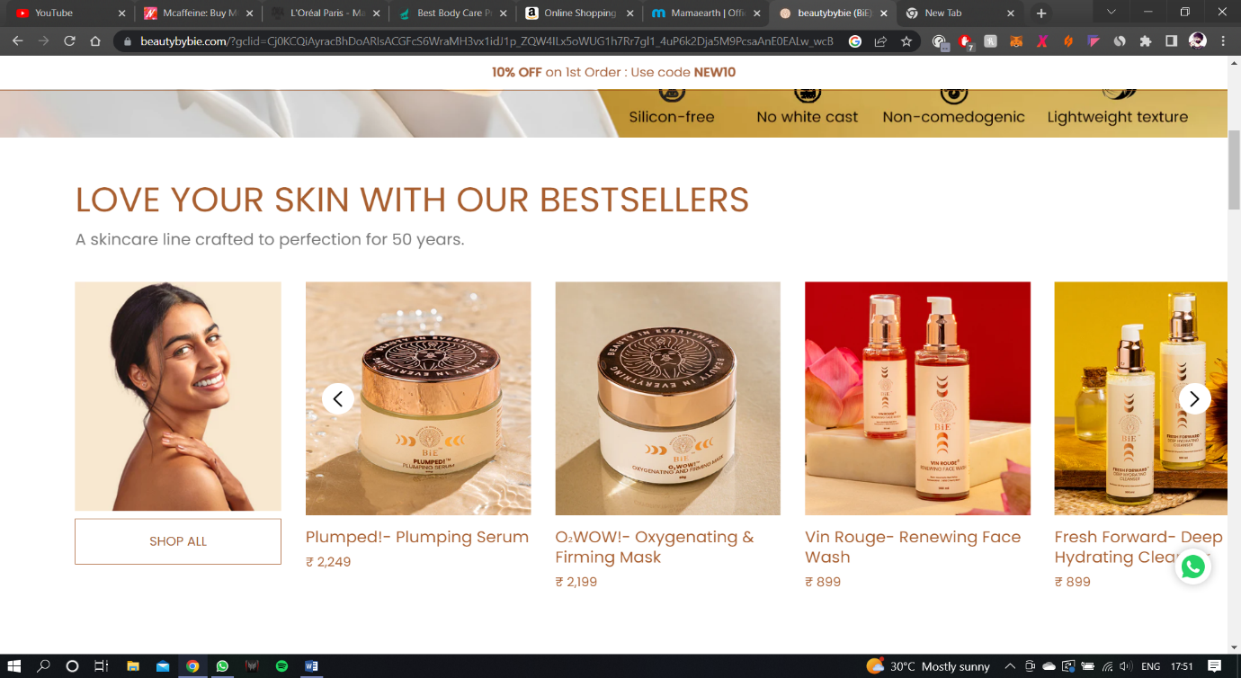

<https://beautybybie.com/?gclid=Cj0KCQiAyracBhDoARIsACGFcS6WraMH3vx1idJ1p_ZQW4ILx5oWUG1h7Rr7gl1_4uP6k2Dja5M9PcsaAnE0EALw_wcB>

u can check this website out it has extremely good ui!

My bro this is the tricky part. U need to make 5 scrollable rows with dummy cards but leave space on the left side for text on each row. In this example there is a unscrollable image on left side, just leave some space we’ll add text later there.

**STEP 4:**

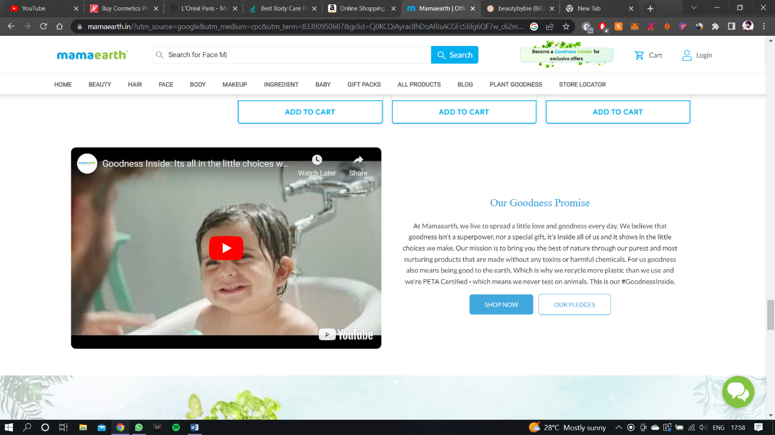

**BRO THEY BRAGGIN!!**

Add container for text on left and image on right so we can brag to.

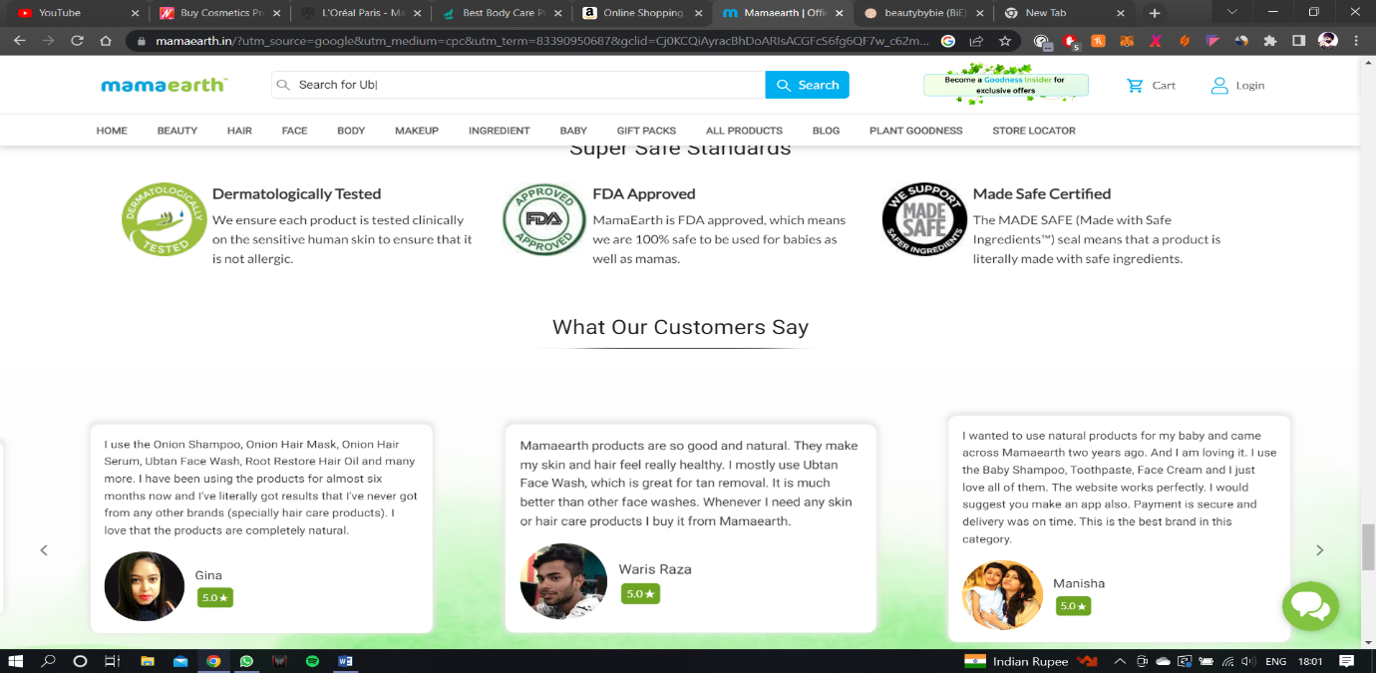

If u can make a cool section like above for us too so we can brag more.

**STEP 5:**

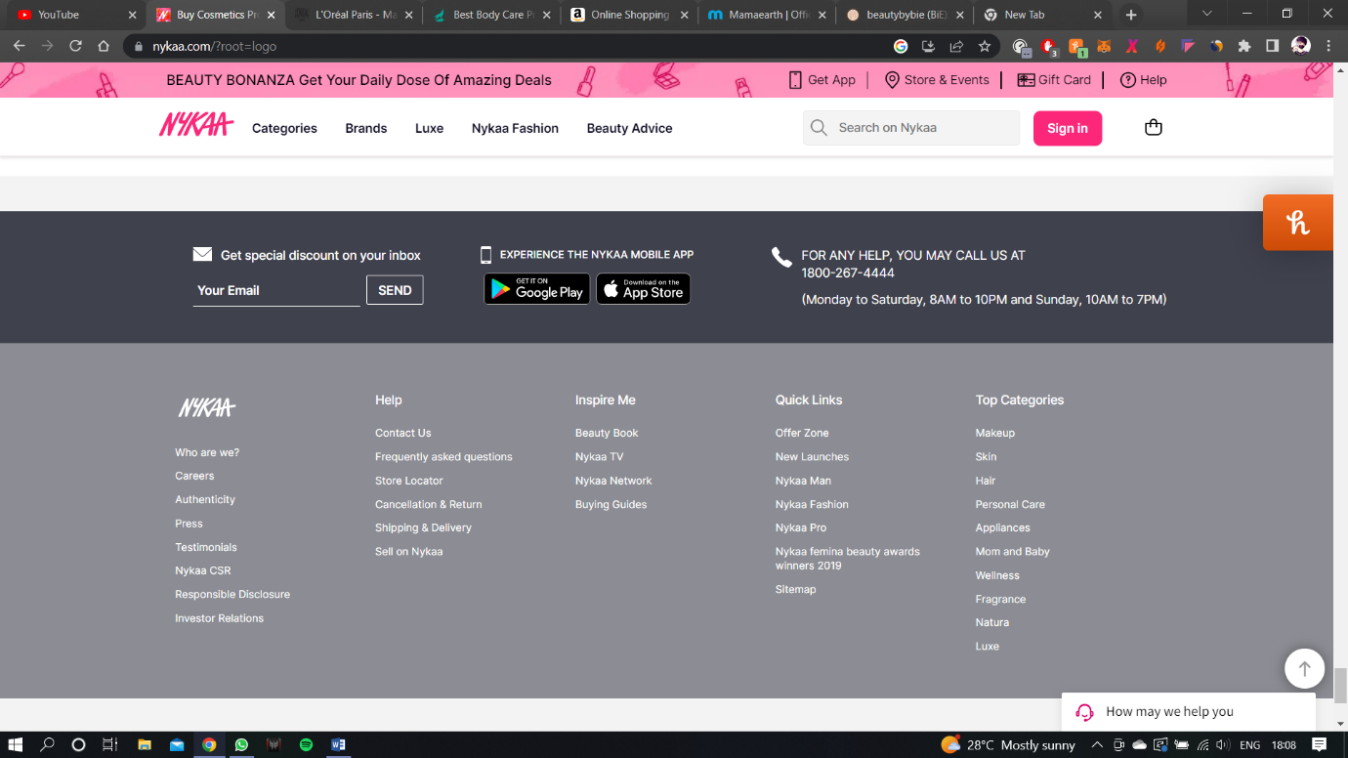

Make the ending thingy like quick links, contact us etc   
AND U R DONE MY BRO!!!!

**I REPEAT: MY BRO SHOULD COPY CODES FROM GOOGLE OR DIRECTLY FROM WEBSITES IN ORDER TO BE EFFICIENT**